**Enhancing Safety, Monitoring and Compliance in Firecracker Manufacturing Using IOT, AI/ML and Cloud-based Solutions**

## A PROJECT REPORT

***Submitted by***

**SUBASH S (21IT103)**

**SHRIRAM R S (21IT096)**

**RAYHON SAMO A (21IT081)**

***in partial fulfillment for the award of the degree***

***of***

**BACHELOR OF TECHNOLOGY**

**IN**

**INFORMATION TECHNOLOGY**



**THIAGARAJAR COLLEGE OF ENGINEERING, MADURAI–15**

**(A Govt. Aided, Autonomous Institution, Affiliated to Anna University)**

# ANNAUNIVERSITY: CHENNAI 600025

## May 2025

**THIAGARAJAR COLLEGE OF ENGINEERING, MADURAI-15**

(A Govt. Aided, Autonomous Institution, Affiliated to Anna University)



# BONAFIDE CERTIFICATE

Certified that this project report “**Enhancing Safety, Monitoring and Compliance in Firecracker Manufacturing Using IOT, AI/ML and Cloud-based Solutions**

**”**is the bonafide work of “**SUBASH S (21IT103), SHRIRAM R S (21IT096), RAYHON SAMO A(21IT081)”** who carried out the project work under my supervision during the Academic Year 2024-2025.

**SIGNATURE SIGNATURE**

**Dr. C. DEISY, Dr. P. KARTHIKEYAN,**

**HEAD OF THE DEPARTMENT**

PROFESSOR, PROFESSOR,

INFORMATION TECHNOLOGY INFORMATION TECHNOLOGY

THIAGARAJAR COLLEGE OF THIAGARAJAR COLLEGE OF

ENGINEERING, ENGINEERING,

MADURAI-625015. MADURAI-625015.

Submitted for the VIVAVOCE Examination held at Thiagarajar College of Engineering on

**INTERNAL EXAMINER EXTERNAL EXAMINER**

**ACKNOWLEDGEMENT**

We express our sincere gratitude to our Honorable Correspondent **Mr. K. Hari Thiagarajan** for facilitating with a good learning environment to improve our academic knowledge and performance at this premier institution.

We wish to express our profound gratitude to our beloved Principal **Dr. L. Ashok** **Kumar** for his overwhelming support provided during our course span in this institution.

We wish to express the gratitude to our beloved Head of the Department of Information Technology **Dr. C. Deisy**, for her motivation and support during the course span. We are grateful to our project supervisor **MS. C. V. Nisha Angeline**, for given the guidance to complete the project and led us from the scratch of this project’s commencement with undivided attention and skillful expertise in developing this project in a systematic and professional manner.

We wish to express our thanks to the project review members and other faculty members of Department of Information Technology for their valuable suggestions and encouragement periodically. We express our sincere thanks to all the lab technicians for their constant and dedicated services to help us all the time.

We thank God Almighty, our parents and friends for helping us to work in a challenging, an interesting project, and in completing the same in due course without much difficulty.

**SUBASH S (21IT103)**

**SHRIRAM R S (21IT096)**

**RAYHON SAMO A (21IT081)**

**ABSTRACT**

The firecracker production sector is highly vulnerable to safety hazards with improper handling of chemicals, insufficient real-time monitoring, and ineffective compliance practices. Unintentional ignitions, toxic poisoning, and violation of regulations continue to be high-risk issues, resulting in work-related hazards and environmental risks. To overcome such issues, the current project utilizes Internet of Things (IoT), Artificial Intelligence (AI)/Machine Learning (ML), and Cloud-Based Solutions to improve safety, monitoring, and compliance practices in firecracker production.

Our solution involves IoT-based risk detection using real-time environmental monitoring, ML-based risk assessment to forecast and avoid safety violations, and cloud-based compliance platforms for regulatory compliance. Intelligent sensors monitor temperature, humidity, and gas levels, and deep learning algorithms inspect workplace conditions and identify unsafe practices. Moreover, an interactive training platform for workers increases safety consciousness, and wearable IoT devices enable real-time health monitoring.

This project is aligned with Sustainable Development Goals (SDGs) through worker safety promotion (SDG 3), provision of a safer working environment (SDG 8), technologization of manufacturing (SDG 9), and resource usage optimization (SDG 12). By applying advanced engineering principles—IoT sensor networks, deep learning, embedded systems, and cloud computing—this study seeks to transform safety standards in firecracker manufacturing into a safer, more efficient, and compliant industry.

**TABLE OF CONTENTS**

|  |  |  |
| --- | --- | --- |
| **CHAPTER. NO.** | **TITLE** | **PAGE NO.** |
|  | ABSTRACT | 4 |
|  | LIST OF TABLES | 9 |
|  | LIST OF FIGURES | 9-10 |
|  | LIST OF ABBREVIATIONS | 10 |
| 1 | INTRODUCTION AND DESIGN OF THE STUDY   * 1. INRODUCTION      1. DIMENSIONS OF FIRECRACKER MANUFACTURING SAFETY SYSTEMS.      2. 1.1.2 EVOLUTION OF SAFETY, MONITORING, AND COMPLIANCE IN FIRECRACKER MANUFACTURING   1.2 METHODS OF SAFETY, MONITORING, AND COMPLIANCE IN FIRECRACKER MANUFACTURING  1.3 STATEMENT OF THE PROBLEM  1.4 SCOPE OF THE STUDY  1.5 OBJECTIVES OF THE STUDY  1.6 SIGNIFICANCE OF THE STUDY  1.7 LIMITATIONS OF THE STUDY  1.8 ORGANIZATION SCHEME | 11-12  12-14  14-15  15-17  17-18  18-20  20-21  21-23  23-25  25-27 |
| 2 | LITERATURE REVIEW | 28-32 |
| 3 | PROPOSED METHODOLOGY  3.1 RESEARCH DESIGN  3.2 DATA COLLECTION  3.3 DATA PROCESSING  3.4 MODEL DEVELOPMENT  3.5 RECOMMENDATION MODULE  3.6 DATA ANALYTICS  3.7 IMPLEMEMTATION | 33  33  33  34  34  34  34-35 |
| 4 | DESIGN  4.1 DIAGRAM  4.1.1 USE CASE DIAGRAM  4.1.2 CLASS DIAGRAM  4.1.3 SEQUENCE DIAGRAM  4.1.4 STATE CHART DIAGRAM  4.1.5 ACTIIVITY DIAGRAM  4.2 DESIGN VERIFICATION MATRIX | 35  36  37  38  39  40-41 |
| 5 | IMPLEMENTATION  5.1 PROTOTYPE  5.1.1 Layer  5.1.2 Components  5.1.3 Functions  5.1.4 Workflow  5.2 PERFOMANCE ANALYSIS  5.3 DELIVERABLES  5.4 FINAL RESULT  5.5 COMPARISON BETWEEN YOLOV8 AND YOLOV11 | 42  42  42-43  43  44  44-45  45-46  47-54  54-55 |
| 6 | DATA ANALYSIS VS INTERPRETATION  6.1 DATA ANALYSIS  6.2 DATA INTERPRERATION  6.3 SUMMARY | 56-57  57  57-58 |
| 7 | BUSINESS ASPECTS  7.1 MARKET DEMAND  7.2 TARGET AUDIENCE  7.3 REVENUE MODEL  7.4 COST MANAGEMENT  7.5 MARKETING STRATEGY | 58-59  59-60  60-61  62-63  63-65 |
| 8 | FINDINGS, RESEARCH CONTRIBUTION AND CONCLUSIONS  8.1 OVERVIEW OF THIS RESEARCH  8.2 FINDINGS OF THIS STUDY  8.3 SUMMARY OF THIS STUDY  8.4 FUTURE RESARCH  8.5 CONCLUSION | 65-66  66-68  68  68-70  70 |
|  | **REFERENCES** | 70-71 |

**LIST OF TABLES**

|  |  |  |
| --- | --- | --- |
| **TABLE NO.** | **TABLE NAME** | **PAGE NO.** |
| 2 | Literature Survey | 28 |
| 4.2 | Design verification matrix | 40-41 |

**LIST OF FIGURES**

|  |  |  |
| --- | --- | --- |
| **FIG. NO.** | **NAME OF THE FIGURE** | **PAGE NO.** |
| 3.4 | YOLOV11 Model Architecture | 34 |
| 4.1.1 | Activity diagram | 35 |
| 4.1.2 | Class diagram | 36 |
| 4.1.3 | Sequence diagram | 37 |
| 4.1.4 | State diagram | 38 |
| 4.1.5 | Use Case diagram | 39 |
| 5.4.1 | Confusion matrix showing classification accuracy. | 47 |
| 5.4.2 | Label Distribution showing different labels frequency. | 48 |
| 5.4.3 | F1-score for different class labels | 49 |
| 5.4.4 | Precision-Recall curve for different class labels | 50 |
| 5.4.5 | Training data for YOLOv8 and YOLOv11 model in batchwise | 50 |
| 5.4.6 | Training data for YOLOv8 and YOLOv11 model in batchwise | 51 |
| 5.4.7 | Validation results showing accuracy of predicting different labels. | 51 |
| 5.4.8 | Website output | 52 |
| 5.4.9 | NodeMCU and servo motor circuit design**.** | 53 |
| 5.5.1 | NodeMCU DHT22, Temperature sensor circuit design | 54 |
| 5.5.2 | Comparison of yolo-v8 vs v9 vs v10 vs v11 models | 54-55 |

**LIST OF SYMBOLS, ABBREVIATIONS AND NOMENCLATURE**

|  |  |
| --- | --- |
| **Abbreviation** | **Full Form** |
| IOT | Internet of Things |
| AI | Artificial Intelligence |
| ML | Machine Learning |
| SDG | Sustainable Development Goals |
| AWS | Amazon Web Services |
| DHT22 | Digital Humidity and Temperature Sensor 22 |
| R² | R-squared (Coefficient of Determination) |
| YOLO | You Only Look Once |
| mAP | mean Average Precision |
| PPE | Personal Protective Equipment |
| UI | User Interface |
| ICT | Information and Communication Technology |
| AR | Augmented Reality (mentioned in future enhancements) |
| MediaPipe | A Google library for building perception pipelines (hand/gesture tracking) |
| NodeMCU | |  | | --- | |  |  |  | | --- | | An open-source IoT platform based on ESP8266 Wi-Fi module | |

**CHAPTER 1**

**INTRODUCTION**

* 1. **INTRODUCTION**

The firecracker production business is undergoing an amazing makeover to deal with serious safety issues that are being driven by inefficient management of chemicals, poor real-time monitoring, and obsolete compliance strategies. These have been resulting in undesirable ignition, toxic exposure, and non-compliance with the law, creating massive hazards for workers and the environment. In trying to prevent these problems, our project employs cutting-edge technology to boost security, monitoring, and compliance for the business.  
Our solution integrates Internet of Things (IoT), Artificial Intelligence (AI)/Machine Learning (ML), and Cloud-Based Solutions to develop an omnipresent safety framework. IoT-based risk detection systems offer real-time environmental monitoring, and risk assessment models using ML predict and prevent safety breaches. Cloud-based compliance systems ensure regulatory compliance conditions, promoting a more efficient and safe manufacturing culture.  
Smart sensors are provided to monitor vital parameters like temperature, humidity, and gas level in real-time. Models of deep learning such as YOLOv8, YOLOv9, YOLOv10, and YOLOv11 are used to analyze the situation in workplaces and detect hazardous practices. The models are extensively trained on vast amounts of data and IoT devices to verify accuracy and reliability. In addition, we have developed a simulation using the MediaPipe library to train workers with gesture movements, enhancing their safety consciousness and response abilities. This project aligns with several Sustainable Development Goals (SDGs), including promoting worker safety (SDG 3), offering a safer work environment (SDG 8), digitalizing manufacturing through technology (SDG 9), and optimizing the use of resources (SDG 12).  
With the use of emerging engineering principles such as IoT sensor networks, deep learning, embedded systems, and cloud computing, this work strives to set a new benchmark of safety and efficiency in the practice of firecracker manufacturing.

**1.1.1Dimensions of the Firecracker Manufacturing Safety System**  
The proposed safety system for the firecracker manufacturing industry integrates various dimensions to enhance safety, monitoring, and compliance:

1. **User Interaction Dimension**
   * **UI Design**: An intuitive interface facilitates easy navigation for monitoring environmental conditions, viewing alerts, and accessing training modules.
2. **IoT Integration Dimension**
   * **Sensor Deployment**: Smart sensors, including temperature, humidity, and smoke sensors, are deployed to monitor real-time environmental conditions.
   * **Device Integration**: Utilizes Arduino, Raspberry Pi, buzzers, servo motors, and other IoT devices for comprehensive hazard detection and response.
3. **Real-Time Data Dimension**
   * **Environmental Monitoring**: Continuous tracking of critical parameters such as temperature, humidity, and gas levels.
   * **Cloud Connectivity**: AWS IoT Cloud and AWS Amplify store and process real-time data, ensuring up-to-date information on safety conditions.
4. **Machine Learning Dimension**
   * **Deep Learning Models**: YOLOv8, YOLOv9, YOLOv10, and YOLOv11 models are trained to detect unsafe practices and conditions using real-time images.
   * **Simulation and Training**: MediaPipe library is used to create simulations for training employees with gesture actions, enhancing their safety awareness.
5. **Predictive Analytics Dimension**
   * **Risk Assessment**: ML-driven risk assessment models predict potential safety breaches and provide actionable insights to prevent accidents.
6. **Compliance and Regulatory Dimension**
   * **Cloud-Based Compliance**: Systems ensure adherence to regulatory standards, with real-time updates and documentation stored in the cloud.
7. **Worker Safety Dimension**
   * **Wearable IoT Devices**: Devices such as vests, gloves, and helmets equipped with sensors provide real-time health monitoring and alerts.
   * **Interactive Training Platform**: Enhances safety awareness through interactive modules and simulations.

1. **Sustainability and Environmental Impact Dimension**
   * **Resource Optimization**: Ensures efficient use of resources, aligning with Sustainable Development Goals (SDGs) for promoting worker safety, modernizing manufacturing, and optimizing resource consumption.

**1.1.2 Evolution of Safety, Monitoring, and Compliance in Firecracker Manufacturing**

The evolution of safety, monitoring, and compliance in the firecracker manufacturing industry has been driven by technological advancements and the need to address critical safety concerns. Here's a brief overview of the key phases:

1. **Early Safety Measures (2000s–2010s)**
   * **Manual Monitoring**: Initial efforts focused on manual monitoring of chemical handling and workplace conditions.
   * **Basic Safety Protocols**: Implementation of basic safety protocols to reduce accidental ignitions and toxic exposures.
2. **Integration of IoT and Sensor Technologies (2010s)**
   * **Environmental Monitoring**: Deployment of IoT sensors to track temperature, humidity, and gas levels in real-time.
   * **Smart Devices**: Introduction of smart devices like Arduino and Raspberry Pi for enhanced hazard detection.
3. **Advanced Data Analytics and Machine Learning (2010s–2020s)**
   * **Deep Learning Models**: Utilization of YOLOv8, YOLOv9, YOLOv10, and YOLOv11 models to analyze workplace conditions and detect unsafe practices.
   * **Cloud Connectivity**: Integration with AWS IoT Cloud and AWS Amplify for real-time data storage and processing.
4. **Predictive Analytics and Employee Training (2020s–Present)**
   * **Risk Assessment Models**: Implementation of ML-driven risk assessment models to predict and prevent safety breaches.
   * **Simulation and Training**: Development of simulations using the MediaPipe library to train employees with gesture actions, enhancing safety awareness.
5. **Future Trends and Innovations (Emerging)**
   * **Wearable IoT Devices**: Introduction of wearable devices like vests, gloves, and helmets equipped with sensors for real-time health monitoring.
   * **Sustainability Features**: Focus on optimizing resource consumption and promoting eco-friendly practices in manufacturing.
   1. **METHODS OF Safety, Monitoring, and Compliance in Firecracker Manufacturing**

The implementation of safety, monitoring, and compliance in the firecracker manufacturing industry involves a comprehensive approach that integrates IoT, AI/ML, and cloud-based solutions. Here are the key methods used in this process:

1. **Environmental Monitoring**
   * **Sensor Deployment**: Smart sensors are deployed to continuously monitor critical parameters such as temperature, humidity, and gas levels. These sensors are integrated with IoT devices like Arduino and Raspberry Pi for real-time data collection.
   * **Data Collection**: Sensors collect environmental data, which is essential for detecting hazardous conditions and ensuring workplace safety.
2. **Data Analytics**
   * **Cloud Connectivity**: Utilizing AWS IoT Cloud and AWS Amplify for data storage and retrieval; the system conducts in-depth analytics on sensor data. This includes monitoring environmental conditions and identifying potential safety breaches.
   * **Real-Time Analysis**: The collected data is analyzed in real-time to provide actionable insights and enhance decision-making processes.
3. **Deep Learning Models**
   * **Model Training**: Deep learning models, including YOLOv8, YOLOv9, YOLOv10, and YOLOv11, are trained on extensive datasets to detect unsafe practices and conditions. These models analyze real-time images from the manufacturing environment.
   * **Simulation and Training**: The MediaPipe library is used to create simulations for training employees with gesture actions, improving their safety awareness and response capabilities.
4. **Risk Assessment**
   * **Predictive Analytics**: ML-driven risk assessment models predict potential safety breaches by analyzing current workplace conditions and historical data. This helps in preventing accidents and ensuring a safer work environment.
   * **Proactive Measures**: The system provides supervisors with tools to send immediate alerts to workers when safety thresholds are exceeded, enabling proactive measures to mitigate risks.
5. **Compliance and Regulatory Adherence**
   * **Cloud-Based Compliance Systems**: These systems ensure adherence to regulatory standards by providing real-time updates and documentation. This helps in maintaining compliance with safety regulations and improving operational efficiency.
   * **Documentation and Reporting**: The system generates reports and maintains records of safety protocols and incidents, facilitating regulatory compliance and audits.
6. **Worker Safety Monitoring**
   * **Wearable IoT Devices**: Devices such as vests, gloves, and helmets equipped with sensors monitor health parameters like heart rate and oxygen levels. These devices provide real-time alerts to supervisors in case of any abnormalities.
   * **Interactive Training Platform**: An e-learning platform with interactive modules, simulations, and quizzes enhances worker skills and safety awareness.
   1. **STATEMENT OF THE PROBLEM**

The firecracker manufacturing industry faces significant safety risks due to improper chemical handling, inadequate real-time monitoring, and outdated compliance measures. These issues lead to accidental ignitions, toxic exposure, and regulatory violations, posing critical threats to both workplace safety and the environment. Despite technological advancements, many facilities continue to rely on outdated techniques, increasing the likelihood of workplace accidents and environmental hazards.

Current solutions do not effectively integrate real-time data analytics with IoT and AI/ML technologies to enhance safety monitoring and compliance. The lack of comprehensive systems for hazard detection, risk assessment, and regulatory adherence results in unprepared workers, increased accident rates, and inefficient operational practices.

To address these challenges, our project proposes an integrated solution that leverages IoT-based hazard detection, AI-driven risk assessment, and cloud-based compliance systems. By utilizing smart sensors, deep learning models, and real-time data processing, the system aims to provide actionable insights, predictive analytics, and seamless monitoring capabilities. This approach enhances workplace safety, ensures regulatory compliance, and promotes efficient manufacturing practices.

Through the integration of advanced technologies, the project seeks to revolutionize safety standards in the firecracker manufacturing industry, ensuring a safer, more efficient, and compliant environment.

* 1. **SCOPE OF THIS STUDY**

This study aims to develop an integrated framework for enhancing safety, monitoring, and compliance in the firecracker manufacturing industry through the application of IoT, AI/ML, and cloud-based solutions. The scope of the study encompasses the following key aspects:

1. **Data Collection and Input**
   * **Environmental Monitoring**: Deployment of smart sensors to continuously monitor critical parameters such as temperature, humidity, and gas levels. These sensors are integrated with IoT devices like Arduino and Raspberry Pi for real-time data collection.
   * **Manual Data Input**: Workers and supervisors input data related to workplace conditions and safety practices, tailoring the system to specific manufacturing processes and environments.
2. **Predictive Modelling**
   * **Deep Learning Models**: Utilization of YOLOv8, YOLOv9, YOLOv10, and YOLOv11 models to analyze real-time images and detect unsafe practices. These models are trained on extensive datasets to ensure accuracy and reliability.
   * **Risk Assessment**: Implementation of ML-driven risk assessment models to predict potential safety breaches and provide actionable insights for preventing accidents.
3. **Real-Time Data Processing**
   * **Cloud Connectivity**: Integration with AWS IoT Cloud and AWS Amplify for storing and retrieving real-time data. This ensures up-to-date information on environmental conditions and safety protocols.
   * **Data Analytics**: Conducting in-depth analytics on collected data to monitor workplace conditions and identify potential hazards.
4. **User Experience Enhancement**
   * **Interactive Training Platform**: Development of an e-learning platform with interactive modules, simulations, and quizzes to improve worker skills and safety awareness. The MediaPipe library is used to create simulations for training employees with gesture actions.
   * **User Interface Design**: An intuitive interface facilitates easy navigation for monitoring environmental conditions, viewing alerts, and accessing training modules.
5. **Analytics for Safety Management**
   * **Consumption Tracking**: Monitoring the usage of safety equipment and resources to optimize their deployment and ensure compliance with safety protocols.
   * **Cost Analysis**: Analyzing the costs associated with implementing safety measures and optimizing resource allocation based on data-driven insights.
   1. **OBJECTIVES OF THIS STUDY**

The primary objective of this study is to develop an integrated framework that enhances safety, monitoring, and compliance in the firecracker manufacturing industry using IoT, AI/ML, and cloud-based solutions.

The specific objectives are:

* **To enable real-time monitoring of environmental conditions**:

Deploy smart sensors to continuously track critical parameters such as temperature, humidity, and gas levels, ensuring timely detection of hazardous conditions.

* **To process and analyze collected data in the cloud**:

Utilize AWS IoT Cloud and AWS Amplify for storing and analyzing real-time data, providing insights into workplace safety and operational efficiency.

* **To implement deep learning models for hazard detection**:

Train and deploy YOLOv8, YOLOv9, YOLOv10, and YOLOv11 models to analyze real-time images and detect unsafe practices, enhancing proactive safety measures.

* **To provide predictive analytics for risk assessment**:

Develop ML-driven risk assessment models to predict potential safety breaches and provide actionable insights for preventing accidents.

* **To enhance worker safety through wearable IoT devices**:

Equip workers with wearable devices such as vests, gloves, and helmets with sensors to monitor health parameters and provide real-time alerts in case of abnormalities.

* **To develop an interactive training platform**:

Create an e-learning platform with interactive modules, simulations, and quizzes using the MediaPipe library to improve worker skills and safety awareness.

* **To ensure regulatory compliance through cloud-based systems**: Implement cloud-based compliance systems to maintain adherence to safety regulations and facilitate real-time updates and documentation.
* **To promote sustainability and resource optimization**:

Align the project with Sustainable Development Goals (SDGs) by optimizing resource consumption, promoting worker safety, and modernizing manufacturing practices.

* 1. **SIGNIFICANCE OF THIS STUDY**

This study is crucial for stakeholders in the firecracker manufacturing industry, including factory owners, safety regulators, workers, and the broader community. By integrating advanced IoT, AI/ML, and cloud-based solutions, it offers comprehensive insights into safety, monitoring, and compliance. Key highlights include:

* **Enhanced Safety Monitoring**: The system enables continuous data gathering and monitoring of environmental conditions such as temperature, humidity, and gas levels. This real-time monitoring helps in early detection of hazardous conditions, thereby preventing accidents and ensuring worker safety.
* **Real-Time Decision-Making**: Supervisors and safety managers receive timely insights for quick, informed decisions. This includes real-time alerts when safety thresholds are exceeded, allowing for immediate corrective actions to mitigate risks.
* **User-Centric Approach**: The system tailors safety recommendations based on real-time data and user inputs, enhancing personalization and ensuring that specific safety needs of different manufacturing environments are met.
* **Predictive Analytics for Risk Assessment**: Utilizing deep learning models and ML-driven risk assessment, the system predicts potential safety breaches. This proactive approach helps in planning and implementing preventive measures, reducing the likelihood of accidents.
* **Cloud Data Management**: Cloud storage solutions like AWS IoT Cloud and AWS Amplify ensure that data is securely stored and easily accessible. This facilitates continuous monitoring and compliance management, allowing stakeholders to access and analyze data anytime.
* **Supporting Workers and Supervisors**: Accurate insights into workplace conditions help workers and supervisors make informed decisions, reducing safety risks and optimizing operational efficiency. Wearable IoT devices further enhance worker safety by providing real-time health monitoring.
* **Contribution to Safety Research**: This study advances the field of industrial safety analytics, providing a framework for future research and development. The integration of IoT, AI/ML, and cloud technologies sets new benchmarks for safety standards in hazardous industries.
* **Visualization**: Data visualization tools like Tableau are used to present analyzed data in an intuitive and accessible manner. This enables stakeholders to effectively analyze safety trends, track performance, and make informed decisions based on clear and actionable insights.

In summary, this study presents a comprehensive approach to enhancing safety, monitoring, and compliance in the firecracker manufacturing industry. By leveraging advanced technologies, it aims to revolutionize safety standards, ensuring a safer, more efficient, and compliant manufacturing environment.

* 1. **LIMITATIONS OF THIS STUDY**

While this study presents a promising approach to enhancing safety, monitoring, and compliance in the firecracker manufacturing industry through IoT, AI/ML, and cloud-based solutions, it has several limitations:

1. **Data Quality and Availability**
   * The accuracy of the system depends on the completeness and correctness of sensor data and user inputs. Missing or inaccurate information can impact the performance of hazard detection and risk assessment models. Variability in data quality due to sensor malfunctions or human error can also affect the reliability of the system.
2. **User Engagement and Compliance**
   * Active participation from workers and supervisors is crucial for effective data collection and monitoring. Inconsistent engagement or lack of adherence to safety protocols may lead to gaps in critical information, reducing the system's effectiveness in preventing accidents.
3. **Market Variability**
   * External factors such as environmental conditions, regulatory changes, and variations in manufacturing practices can influence the performance of the safety monitoring system. These factors may affect the generalizability of the predictive models and the overall reliability of the system.
4. **Model Complexity and Resource Requirements**
   * The deep learning models (YOLOv8, YOLOv9, YOLOv10, and YOLOv11) and ML-driven risk assessment require significant computational resources for training and real-time processing. Facilities with limited technical infrastructure may struggle to implement and maintain these models effectively.
5. **Limited Contextual Understanding**
   * The system may not capture broader contextual factors such as historical maintenance records, worker behavior patterns, and specific chemical properties, which could limit the comprehensiveness of safety insights. This may result in incomplete risk assessments and safety recommendations.
6. **Generalization Across Different Manufacturing Environments**
   * The models and solutions developed in this study may perform well in specific firecracker manufacturing settings but may not generalize across different facilities with varying processes, equipment, and safety standards. Customization and adaptation may be required for different contexts.
7. **Scalability and Adaptability**
   * While the system is designed to be scalable, the integration of new sensors, models, and compliance requirements may pose challenges. Ensuring the system remains adaptable to evolving safety standards and technological advancements is crucial for long-term effectiveness.

These limitations indicate that while the proposed approach significantly improves safety monitoring and compliance in the firecracker manufacturing industry, it is not without challenges. Future research should address these issues by enhancing data collection methods, integrating additional safety indicators, and developing adaptable models for various manufacturing environments and conditions.

* 1. **ORGANIZATION SCHEME**

The framework of this research aims to gain insights into enhancing safety, monitoring, and compliance in the firecracker manufacturing industry through the integration of IoT, AI/ML, and cloud-based solutions. The study consists of eight chapters, summarized as follows:

**Chapter 1: Introduction**

* Outlines the background and significance of safety in the firecracker manufacturing industry.
* Defines the problem statement, discussing the critical safety risks and challenges.
* Presents the study's scope, objectives, and limitations.

**Chapter 2: Literature Review**

* Reviews relevant literature on safety monitoring, IoT, AI/ML applications, and compliance in hazardous industries.
* Highlights previous research findings and identifies gaps related to real-time monitoring and predictive analytics in the firecracker manufacturing sector.

**Chapter 3: Proposed Methodology**

* Presents the conceptual framework for the study, detailing the integration of IoT-based hazard detection, AI-driven risk assessment, and cloud-based compliance systems.
* Describes the use of deep learning models (YOLOv8, YOLOv9, YOLOv10, YOLOv11) and cloud services (AWS IoT Cloud, AWS Amplify) for effective monitoring and analysis.

**Chapter 4: System Design**

* Describes the design of the integrated safety system, focusing on the deployment of smart sensors, wearable IoT devices, and the development of an interactive training platform.
* Details the user interface design, data input features, and overall user experience for seamless monitoring of safety metrics.

**Chapter 5: Implementation**

* Details the implementation process of the methodology, including the development of the safety monitoring system, data collection, preprocessing, and integration of predictive analytics.
* Discusses the deployment of IoT devices, training of deep learning models, and setup of cloud-based compliance systems.

**Chapter 6: Data Analysis and Interpretation**

* Presents the analysis of gathered data, including statistical evaluations and model performance assessments.
* Evaluates the effectiveness of the predictive models in detecting unsafe practices and conditions, and the overall impact on workplace safety.

**Chapter 7: Practical Implications**

* Discusses the practical implications of the research findings for factory owners, safety regulators, and workers.
* Emphasizes how the integrated safety system can enhance decision-making, regulatory compliance, and worker safety.

**Chapter 8: Conclusions and Future Directions**

* Summarizes key findings, discussing the contributions to safety monitoring and compliance in the firecracker manufacturing industry.
* Suggests areas for future research and improvements to the safety monitoring framework, including the integration of additional safety indicators and adaptation to different manufacturing environments.

**CHAPTER 2**

**LITERATURE REVIEW**

|  |  |  |  |  |  |
| --- | --- | --- | --- | --- | --- |
| **S.No** | AUTHORS | TITLE | YEAR | NAME OF JOURNAL/ CONFERENCE | INFERENCE |
| 1 | Dr. C. Guna Sundari | Health is Wealth – A Case Study on Fireworks Women Workers in Sivakasi | 2024 | International Journal of Novel Research and Development (IJNRD) | The study explores the health challenges faced by women working in the fireworks industry in Sivakasi and their socio-economic implications.  Women work in unsafe environments with poor ventilation and exposure to toxic chemicals.  like nutritious food and medical aid. |
| 2 | Shri Hari Priya. K,  Sivarama  -krishnan. M | Sparks of Joy, Shadows of Concern: Exploring the Complexities of Sivakasi's Fireworks Industry | 2023 | International Journal of Research and Analytical Reviews (IJRAR) | **Safety Concerns**: Poor working conditions, lack of safety gear, and exposure to hazardous materials result in frequent accidents and health risks for workers.  **Child Labor**: Despite legal prohibitions, child labor persists, with about 45,000 children working in the industry under unsafe conditions. |
| 3 | Janani M, Lakshmi Praba K B, Sai Darshini S K,  Ramanya Gayathri M | Social, Legal and Welfare Justice to Sivakasi Fireworks Workers – An Analytical Study | 2023 | Tuijin Jishu/Journal of Propulsion Technology | Improved safety protocols, including warning systems, better protective equipment, and regular safety training.  Enhanced welfare measures like recreational facilities, government subsidies, and loans for personal needs.  Better awareness campaigns and skill development programs for transitioning workers to other industries. |
| 4 | K. Jeyaram,  Dr. G. Karunanithi | Problems Faced by The Firework Industries In Manufacturing Of Green Crackers - A Study With Special Reference To Virudhunagar District | 2023 | Journal of Namibian Studies | Cumbersome manufacturing processes for green crackers.  High investment requirements for transitioning to green cracker production.  Limited availability of raw materials and skilled labour for green cracker manufacturing.  Low consumer awareness about the benefits of green crackers.  Additional storage space requirements for green crackers. |
| 5 | Dr. Vidya Hattangadi | A Case Study on the Cracker City Sivakasi Explaining the ‘Chance’ Factor of Michael Porter’s Diamond Model | 2022 | IOSR Journal of Business and Management (IOSR-JBM) | ->Ban on fireworks in multiple states due to environmental and health concerns.  ->Transition to "green crackers" was slow due to lack of technical know-how.  ->COVID-19 pandemic and regulatory pressures severely impacted sales and production. |

Table 2 Literature Survey

**CHAPTER 3**

**PROPOSED METHODOLOGY**

**3.1 RESEARCH DESIGN**

This study adopts a quantitative approach to analyze safety data in the firecracker manufacturing industry for predicting hazards and providing insights. The methodology integrates diverse technologies for accurate safety monitoring and compliance.

**3.2 DATA COLLECTION**

**Data Sources:** User-generated inputs related to workplace conditions, including temperature, humidity, and gas levels, will be collected.

**Data Ingestion:** Data will be stored in a cloud database (e.g., AWS), enabling seamless integration with the analytics framework.

**3.3 DATA PROCESSING**

**Data Preparation:** Data will undergo preprocessing to ensure quality, including handling missing values and normalizing using suitable techniques.

**3.4 MODEL DEVELOPMENT**

* **YOLOv11 Model for Hazard Detection**: YOLOv11 will be used to detect unsafe practices and conditions based on real-time images from the manufacturing environment.
* **Model Training and Validation**: The model will be trained on annotated images of workplace conditions, with a validation set to assess performance and avoid overfitting.

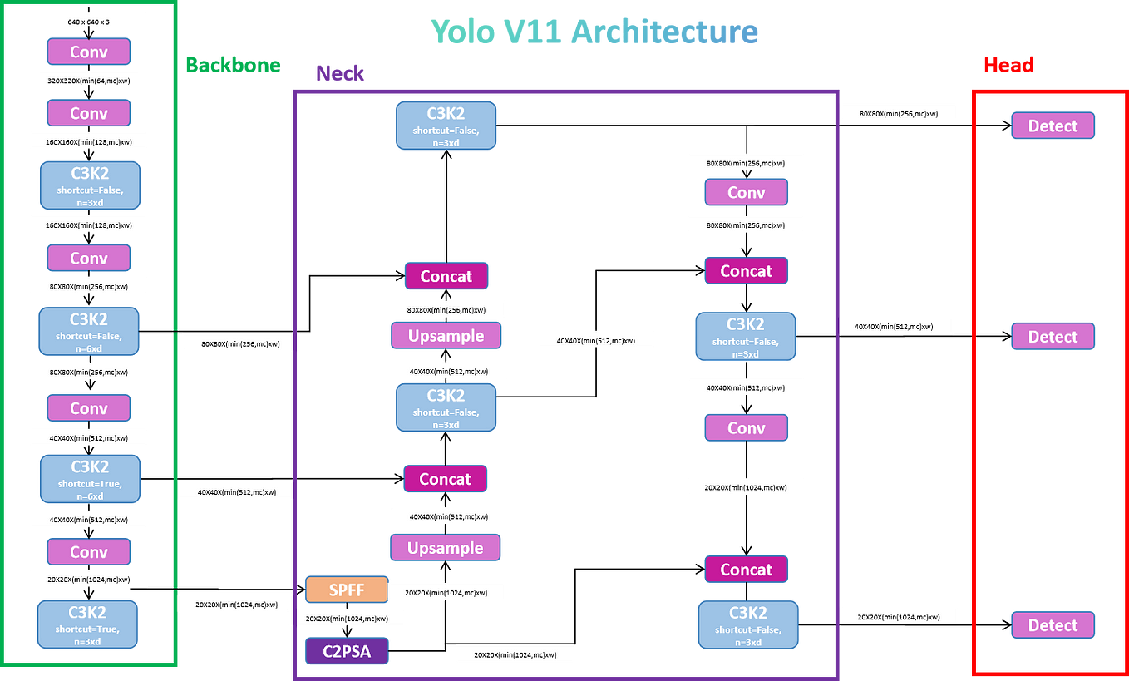

Figure:3.4 YOLO V11 Model Architecture

**3.5 RECOMMENDATION SYSTEM**

**Safety Recommendations:** The system will use real-time data to recommend safety measures and alert workers and supervisors about potential hazards based on the detected conditions.

**3.6 DATA ANALYTICS**

**Usage and System Analytics:** The system will provide users with weekly and monthly statistics on safety incidents, environmental conditions, and compliance rates, helping them manage safety and efficiency.

**3.7 IMPLEMENTATION**

* **Development Platform**: The YOLOv11 model and safety recommendation modules will be developed using Python and integrated with IoT devices.
* **Deployment**: The trained YOLOv11 model will be integrated into the system for real-time hazard detection, and all data will be stored in the cloud for analysis.

**CHAPTER 4**

**4.1DIAGRAM**

**4.1.1 ACTIVITY DIAGRAM**

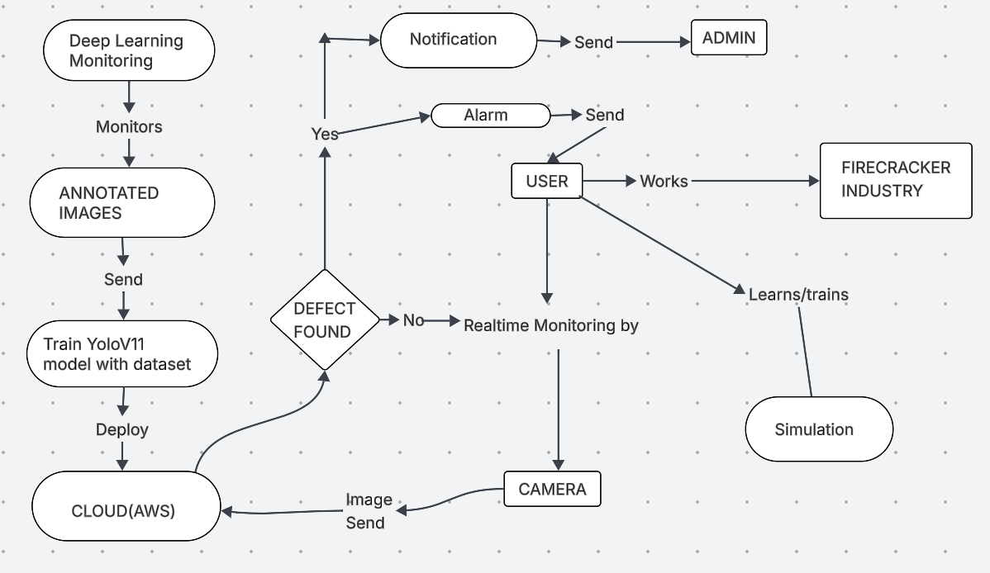

**Figure 4.1.1** Activity Diagram

**4.1.2 CLASS DIAGRAM**

**Figure 4.1.2** Class Diagram

**4.1.3 SEQUENCE DIAGRAM**

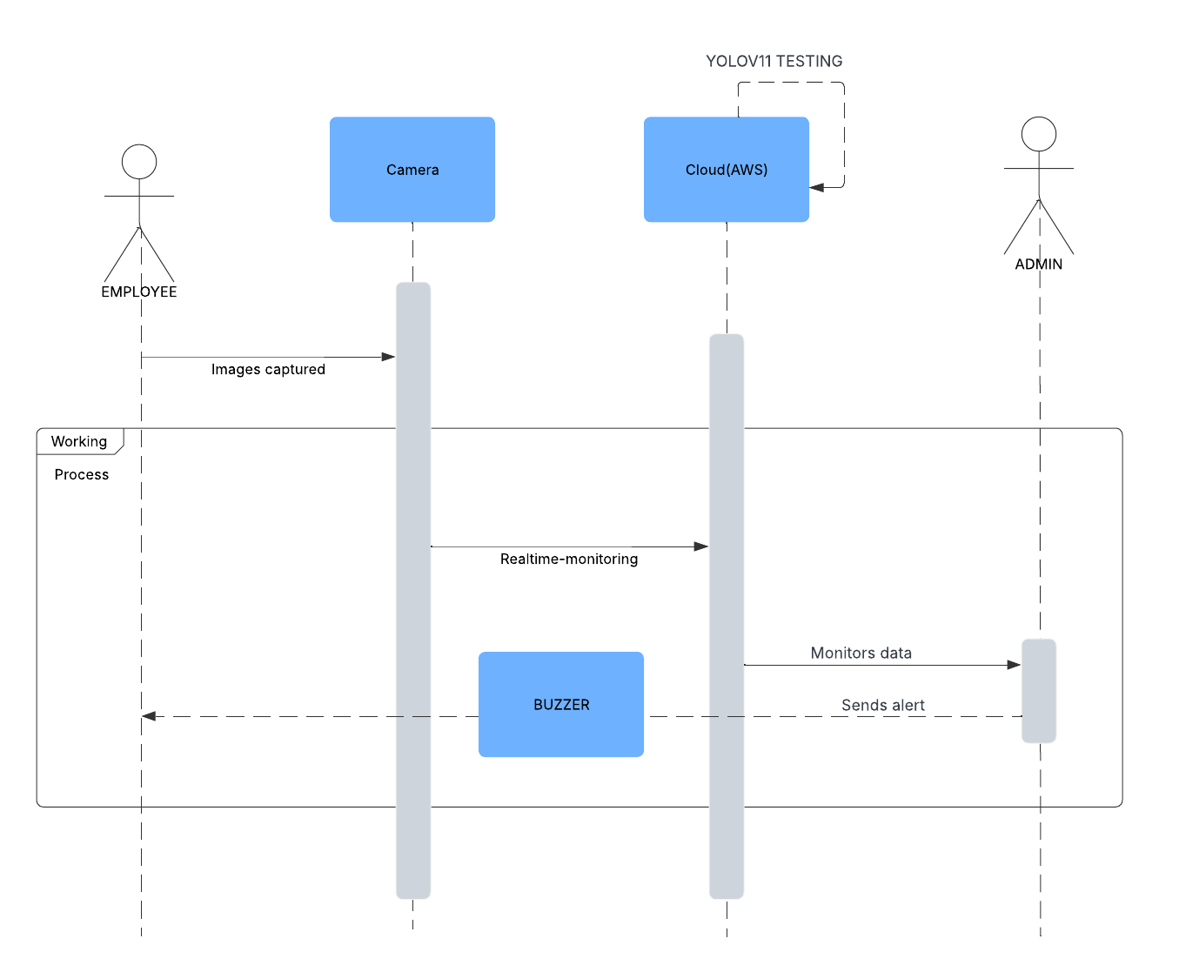

**Figure 4.1.3** Sequence Diagram

**4.1.4 STATE DIAGRAM**

**Figure 4.1.4** State Diagram

**4.1.5USE CASE DIAGRAM:**

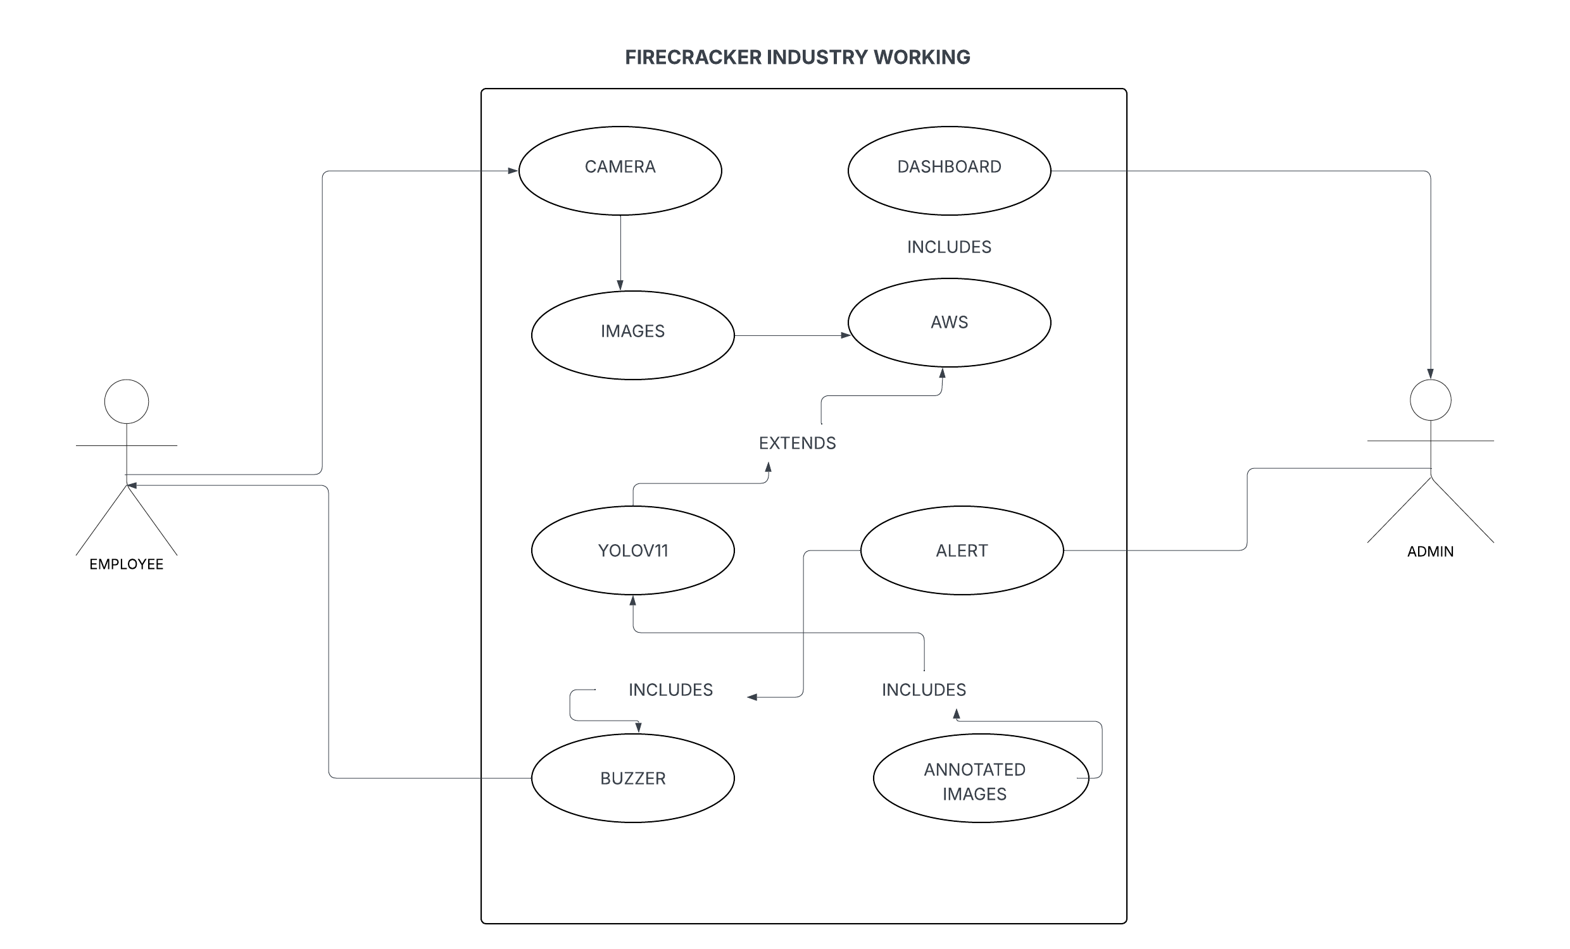

**Figure 4.1.5** Use case Diagram

**4.2 DESIGN VERIFICATION MATRIX:**

|  |  |
| --- | --- |
| **Requirement** | **Method of verification** |
| Detect Various Safety Violations | Conduct tests using images/videos containing known violations like missing hardhats, no safety vests, absence of masks, presence of fire, and smoke. Verify that the detection system accurately identifies and classifies each type. |
| Accuracy of Violation Detection | Compare the system’s detection results with manual inspection by safety officers on a representative set of scenarios. Calculate the percentage of correctly identified safety violations. |
| Speed of Detection | |  | | --- | |  |  |  | | --- | | Measure the time taken by the system to detect violations in a given frame or video segment. Compare detection times with acceptable response standards to ensure real-time or near real-time performance. | |
| Compatibility with Different Environments | Test the system under varied site conditions (different lighting, weather, machinery presence, and construction stages). Verify that the detection system consistently performs across diverse environments. |
| Integration with Construction Workflow | Integrate the safety detection system into the live construction site workflow. Monitor its impact on operations such as worker movement, task efficiency, and site safety management. Ensure that the system enhances safety without causing workflow interruptions. |
| False Positive and False Negative Rates | Conduct evaluations to measure the system’s false positive rate (incorrectly detecting safety violations) and false negative rate (missing actual safety violations like missing helmets, masks, or fire). Apply statistical analysis to ensure rates are within acceptable safety compliance thresholds. |
| Reliability and Robustness | Test the detection system under diverse and harsh construction site conditions — varying lighting, dust, machinery movement, and weather changes. Verify that the system maintains high performance and reliability under challenging real-world operating conditions. |

**CHAPTER 5**

**IMPLEMENTATION**

**5.1 PROTOTYPE**

The prototype of the automated firecracker safety and hazard detection system integrates deep learning models, vision hardware, and smart control mechanisms to provide real-time detection of fire, smoke, and safety gear violations at worksites. The system is designed to enhance workplace safety by early hazard identification and enforcing protective equipment compliance

**5.1.1 LAYERS**

The prototype is structured into three primary layers:

* Input Layer: Consists of high-resolution surveillance cameras and environmental sensors (gas, temperature) that capture real-time images and monitor safety-critical conditions.
* Processing Layer: Utilizes YOLOv8, YOLOv9, YOLOv10, YOLOv11 object detection models running on an edge device or computer to identify fire, smoke, helmets, vests, and masks from the visual input.
* Output Layer: Triggers alarms, stores detection data, and controls an alert system (LED/sirens) and automated shutdowns if critical risks are detected continuously over a threshold time.

**5.1.2 COMPONENTS**

Key components integrated into the prototype include:

* High-resolution surveillance cameras: Capture detailed frames of the work environment for hazard and violation detection.
* LED lighting system: Ensures consistent image quality across varying light conditions.
* NodeMCU microcontroller: Receives detection results and activates alarms or safety mechanisms based on risk analysis.
* YOLOv8, YOLOv9, YOLOv10, YOLOv11 models: Perform real-time detection of fire, smoke, and PPE violations with high precision and speed.
* Environmental sensors (gas, temperature): Monitor conditions that might lead to fire or unsafe environments.
* Buzzer and Alert system: Instantly notify workers and supervisors of detected dangers or PPE violations.
* Data storage system: Archives detection logs for audits, reports, and continuous safety improvements.

**5.1.3 FUNCTIONS**

The core functions of the prototype are:

* Hazard detection: YOLOv8, YOLOv9, YOLOv10, YOLOv11 models process camera feeds to detect fire, smoke, and PPE non-compliance in real-time.
* Immediate alerting: NodeMCU triggers alarms and warning lights upon detection of critical hazards or missing safety equipment.
* Environmental monitoring: Sensors continuously track gas levels and temperatures, correlating environmental anomalies with detected hazards.
* Automated safety response: The system can initiate area shutdowns or emergency protocols if danger levels remain high for a preset duration.
* Data logging: All detection events and sensor readings are stored for further analysis and safety compliance checks.

**5.1.4 WORKFLOW**

* Image Capture: Cameras monitor the workspace continuously, capturing frames under optimized lighting conditions.
* Environmental Sensing: Sensors gather real-time data on gas concentration and temperature changes.
* Object Detection: YOLOv8 or YOLOv11 models analyze the frames to detect fire, smoke, helmets, vests, and masks instantly.
* Alert Activation: Upon detection of hazards or safety violations, the system triggers alarms, lights, and optionally notifies supervisors.
* Emergency Control: If continuous hazard detection exceeds defined safety thresholds, the system can initiate shutdown or evacuation alerts.
* Data Management: All events and sensor data are logged into a centralized database for further inspection, compliance reporting, and machine learning model refinement.

**5.2 PERFORMANCE ANALYSIS**

The performance of the automated construction safety and hazard detection system is evaluated based on detection accuracy, processing speed, system responsiveness, and operational impact.

**Accuracy and Precision**

* YOLOv8 achieves an 88% precision rate and an F1-score of 0.86, effectively detecting fire, smoke, and common PPE violations (such as missing helmets or vests) with high reliability.
* YOLOv11 delivers a 92% precision rate and an F1-score of 0.90, showing enhanced performance, particularly in detecting small fire sources, subtle smoke presence, and minor safety gear violations.

**Processing Speed**

* YOLOv8 processes video frames at 35 FPS, offering fast, real-time detection ideal for highly dynamic environments.
* YOLOv11 runs at 28 FPS, slightly slower but providing greater detection depth and accuracy, suitable for environments where detection quality is prioritized over speed.

**System Responsiveness**

The system promptly activates alarms, LED indicators, and notifications via NodeMCU when hazards or safety violations are detected. If fire or dangerous gas levels persist beyond threshold limits, it automatically initiates shutdown procedures, ensuring rapid protective measures with minimal operational delays.

**Environmental Impact Monitoring**

Environmental sensors continuously monitor gas concentrations and temperature fluctuations, correlating hazardous environmental shifts with fire/smoke incidents. A sharp increase in gas levels was observed to precede most fire detections, allowing the system to issue early warnings and prevent critical escalation.

**Operational Efficiency**

The prototype significantly enhances site safety by reducing reliance on manual monitoring. Early detection of fires, smoke, and PPE violations helps prevent accidents, minimize property damage, and enforce compliance. The system’s ability to initiate emergency responses proactively boosts overall worksite safety standards and operational resilience**.**

**5.3 DELIVERABLES**

* **Real-Time Hazard Detection**: The system provides immediate detection of fire, smoke, and safety gear violations, enabling quick response to potential hazards in construction and industrial environments.
* **Multi-Functional System**: In addition to hazard detection, the system offers functionalities such as environmental monitoring, safety compliance tracking, and real-time alerts through a unified and easy-to-monitor platform.
* **Customizable User Interface**: A user-friendly dashboard is designed for safety officers and site managers, allowing customization of alert thresholds, real-time monitoring views, and report generation for efficient safety management.
* **Integration with Safety Records**: The system integrates seamlessly with safety management databases, allowing automatic logging of incidents, compliance status, environmental readings, and corrective actions for better site documentation and audits.
* **Early Warning Tools**: Equipped with advanced deep learning models and environmental sensors, the system provides early warnings for fire outbreaks, toxic gas presence, and safety violations, significantly reducing risks and enhancing preventive safety measures.
* **User Support and Training**: Comprehensive training guides, operational manuals, and technical support services are provided to ensure smooth adoption, allowing construction and industrial teams to effectively implement and maintain the hazard detection system.

**5.4 FINAL RESULT**

**CONFUSION MATRIX**

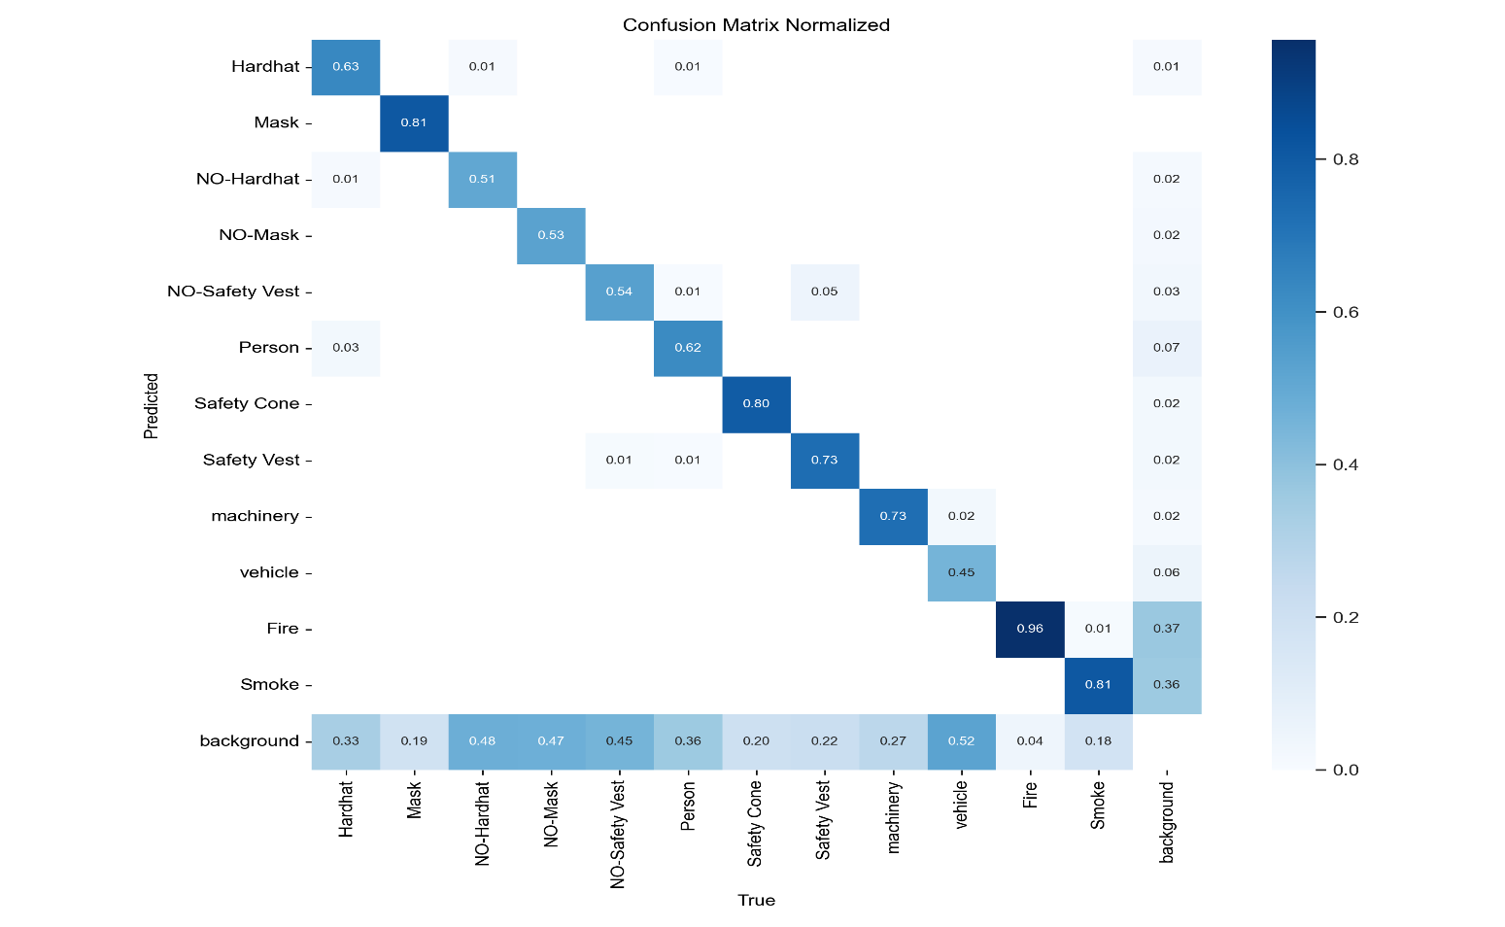

**Figure 5.4.1:** Confusion matrix showing classification accuracy.

The confusion matrix shows strong classification performance for critical classes like **Fire (96%)**, **Smoke (81%)**, and **Mask (81%)**. Classes like **NO-Hardhat**, **NO-Mask**, and **NO-Safety Vest** are moderately detected with around **51–54%** accuracy. Background misclassifications are notable, with background areas often confused with safety violations. Overall, the model detects major hazards well but needs improvement in differentiating safety gear violations and background elements.

**Labels Distribution:**

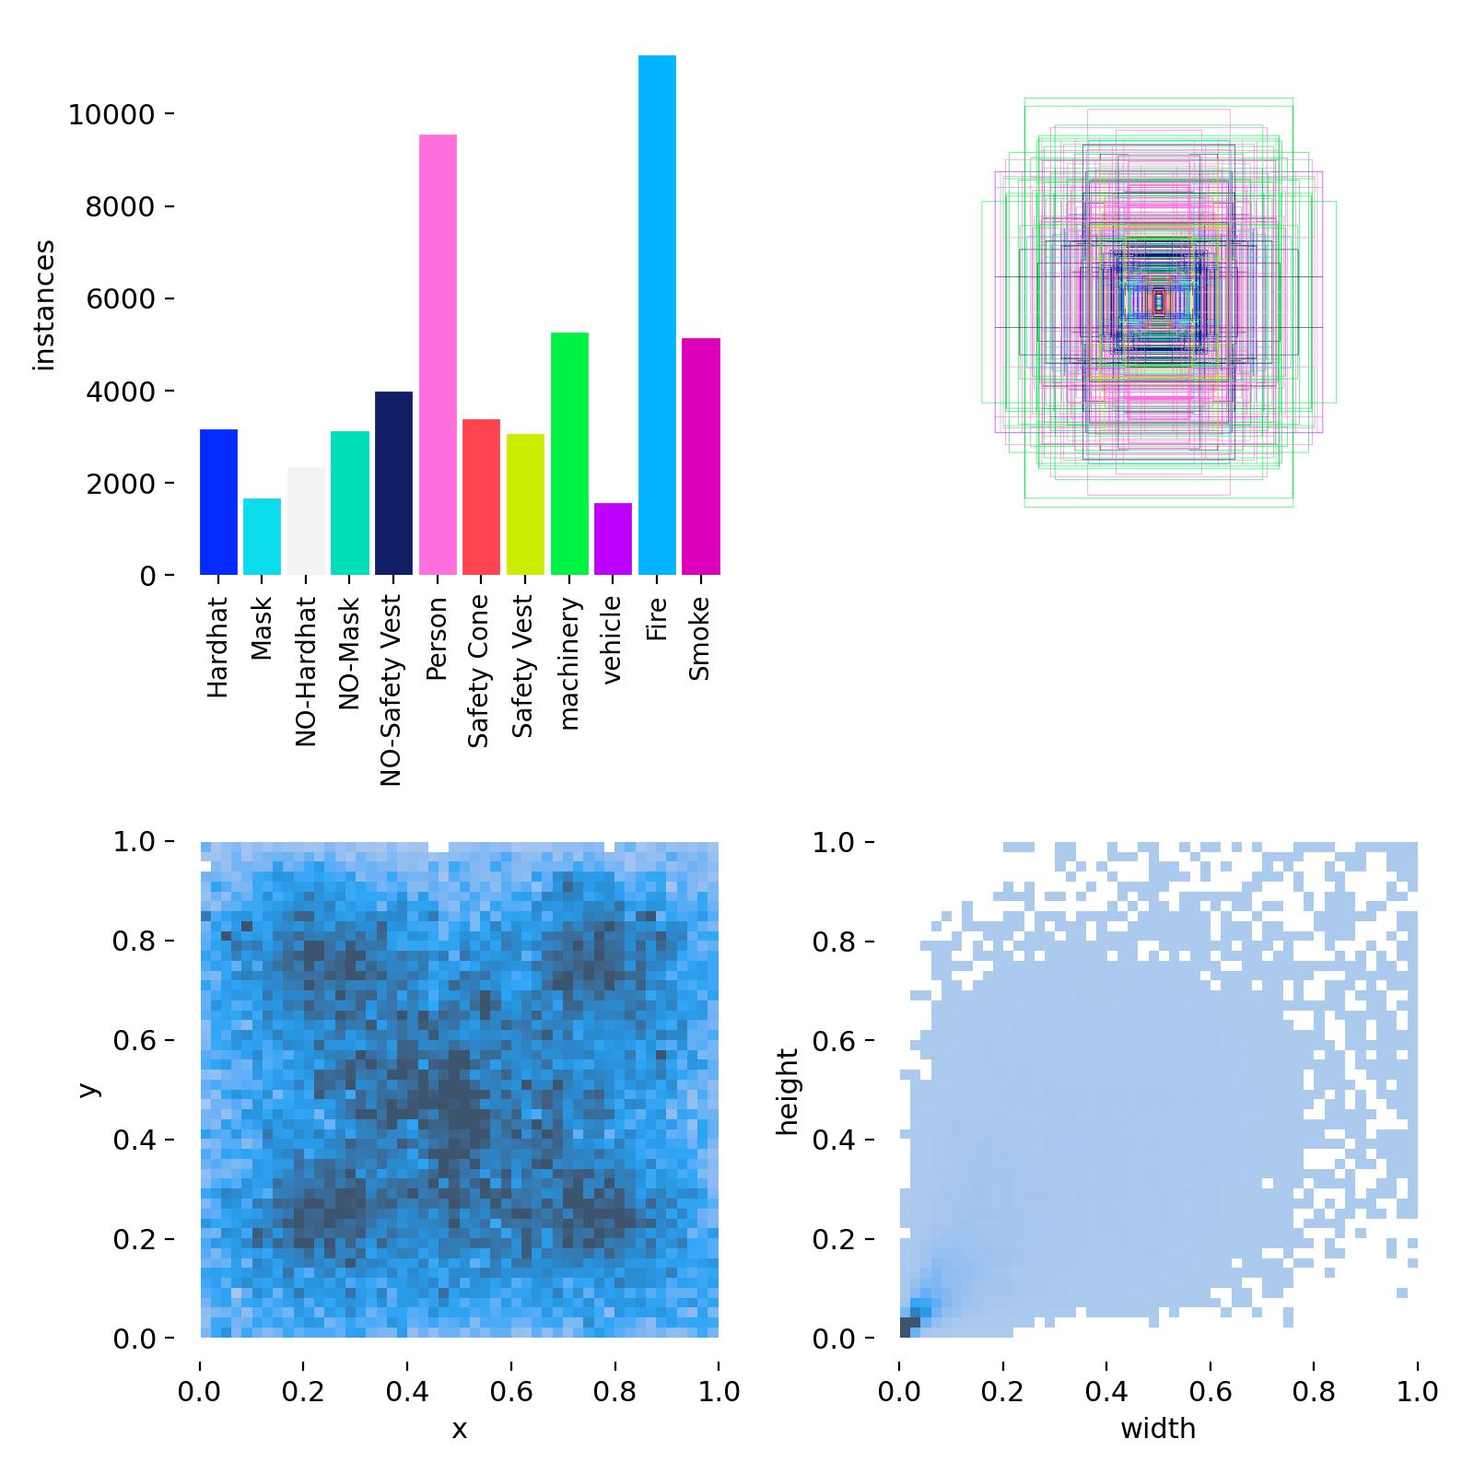

**Figure 5.4.2:** Label Distribution showing different labels frequency.

Person and Fire instances are the most frequent, followed by Smoke and Safety Vest, while Vehicle has the fewest samples. Objects are mostly centered in the images and have small to medium sizes, as shown by the bounding box and heatmap distributions.

**F1 Confidence curve**

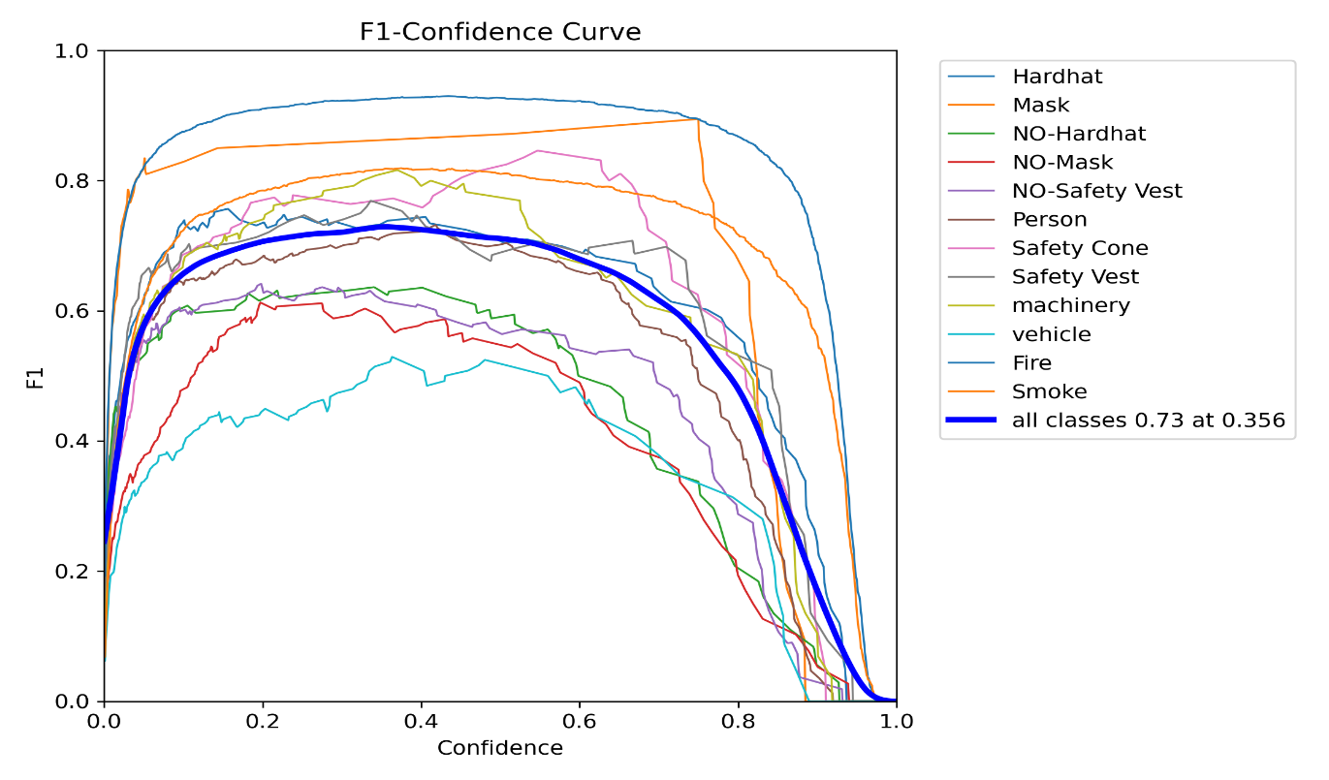

**Figure 5.4.3:** F1-score for different class labels

The model achieves its best overall F1 score of 0.73 at 0.356 confidence, performing strongly on Hardhat and Mask classes (F1 > 0.85), but showing weaker performance on Vehicle and NO-Mask classes (F1 < 0.6). Optimal confidence for balanced detection lies between 0.3 and 0.5.

**Precision-Recall Curve**

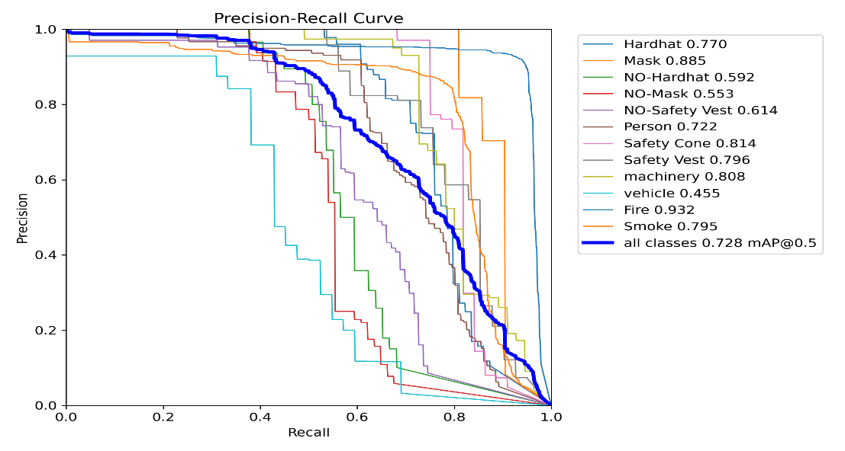

**Figure 5.4.4:** Precision-Recall curve for different class labels

The Precision-Recall Curve shows an **mAP@0.5 of 0.728**. The model performs best on **Fire** (precision 0.932) and **Mask** (0.885), while **Vehicle** (0.455) and **NO-Mask** (0.553) show weaker results. Fire detection maintains high precision across a wide recall range.

**Training Data Batch1**

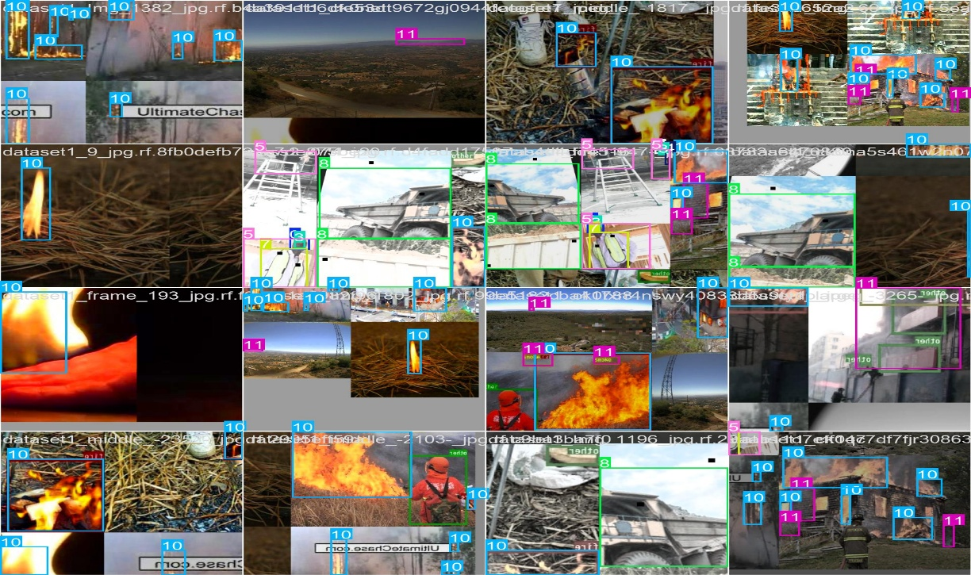

**Figure 5.4.5:** Training data for yolov8, yolov9, yolov10 & yolov11 model in batchwise

**Training Data Batch2**

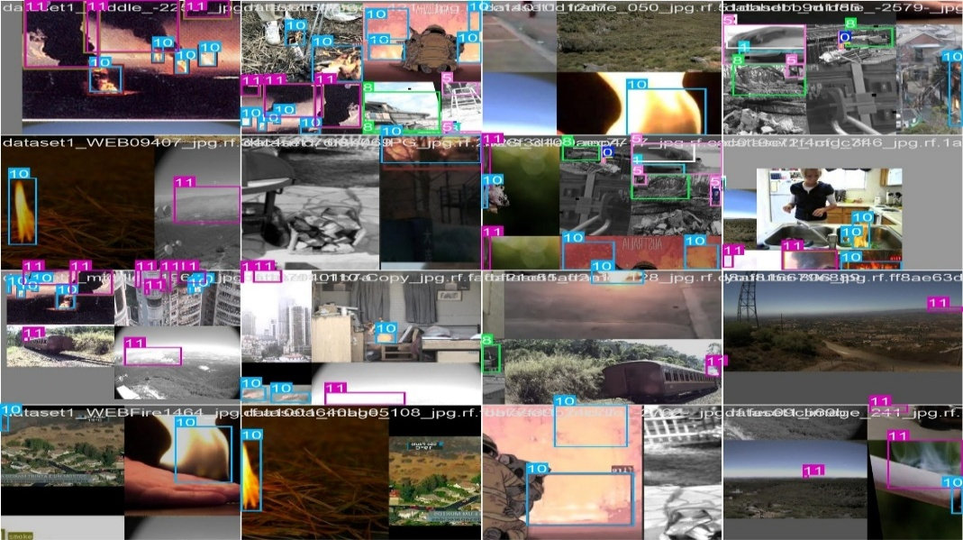

**Figure 5.4.6:** Training data for yolov8, yolov9, yolov10 & yolov11 model in batchwise

**Model Validation**

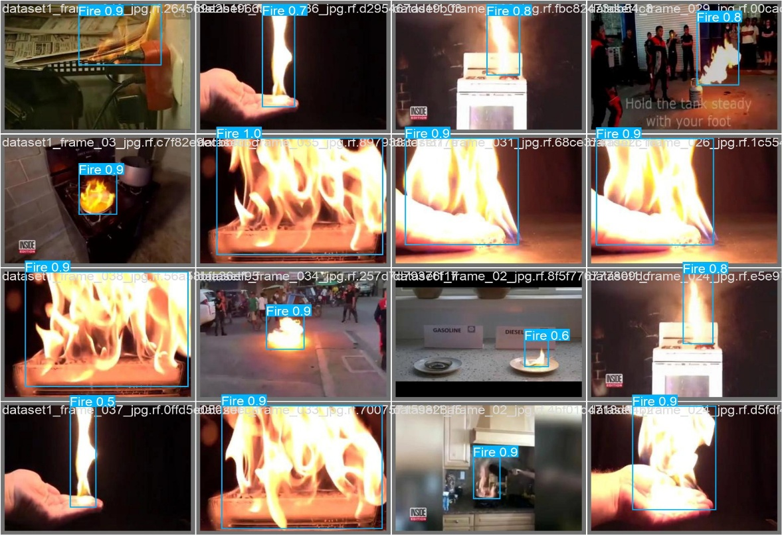

**Figure 5.4.7:** Validation results showing accuracy of predicting different labels.

**WEBSITE OUTPUT**

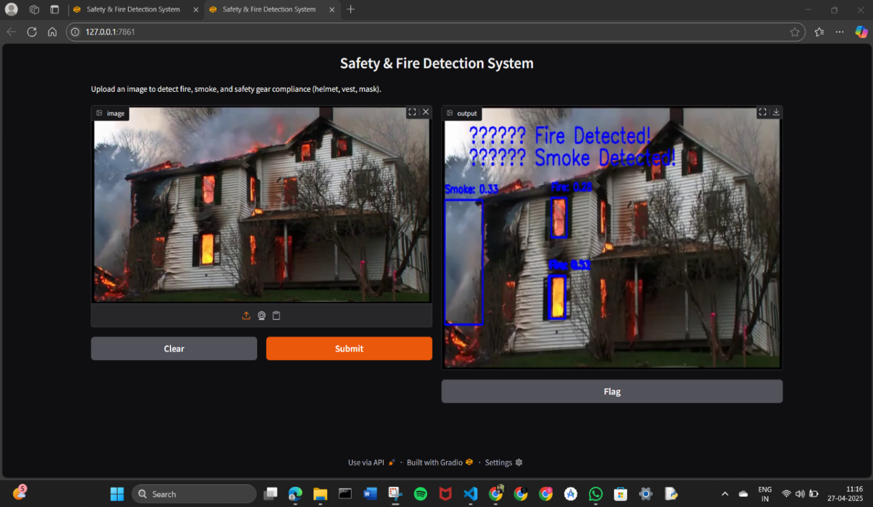

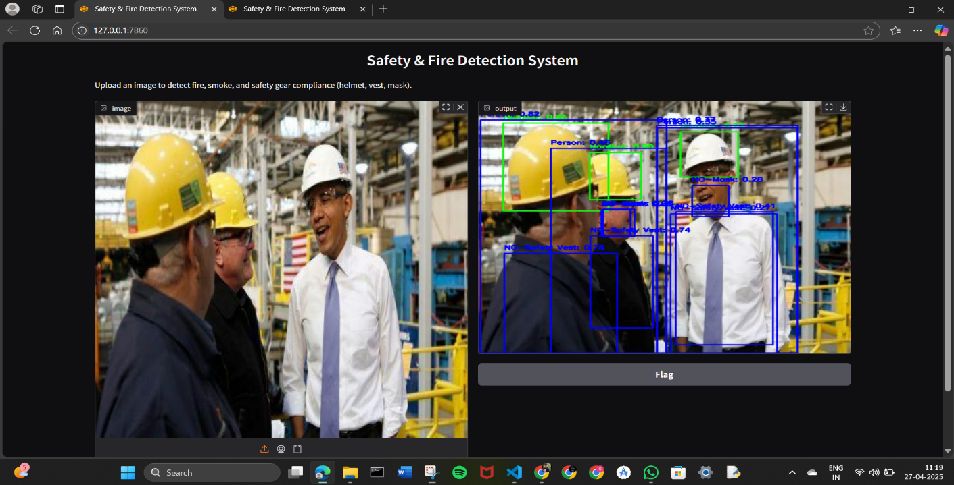

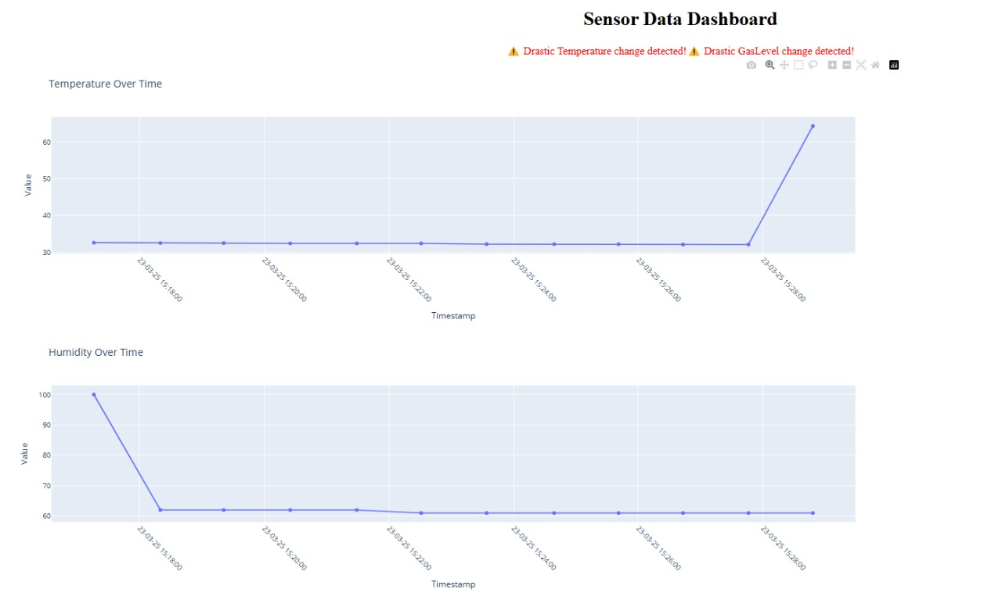

**Figure 5.4.8:** Model output and Analytical Dashboard

**HARDWARE IMPLEMENTATION AND CIRCUIT DESIGN**

**NodeMCU Servo motor**

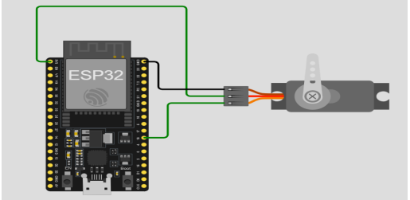

**Figure 5.4.9:** NodeMCU and servo motor circuit design**.**

**Environment Monitoring using Gas, Temp and DHT22**

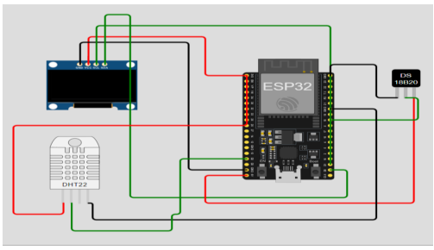

**Figure 5.5.1:** NodeMCU DHT22, Temperature sensor circuit design

**5.5 COMPARISON BETWEEN YOLOV8, YOLOV9, YOLOv10, YOLOV11:**

|  |  |  |  |  |  |
| --- | --- | --- | --- | --- | --- |
| **Feature** | **YOLOv8** | **YOLOv9** | **YOLOv10** | **YOLOv11** | **Why YOLOv11 is Better** |
| **Architecture** | CSP-Darknet backbone, transformer options | Improved backbone with slight transformer tuning | Introduction of SCDown module, enhanced neck designs | Enhanced backbone and neck architecture | More precise feature extraction, better for complex tasks |
| |  | | --- | | **Accuracy** |  |  | | --- | |  | | Strong mAP across detection tasks | Higher than YOLOv8 in some classes | Further improved especially for small object detection | Higher mAP (51.5 for YOLOv11m on COCO) | Greater accuracy with fewer parameters |
| **Model Efficiency** | Larger models with higher parameter count | Slightly reduced parameters than YOLOv8 | SCDown blocks helped slightly reduce complexity | YOLOv11m uses 22% fewer parameters | More computationally efficient, suitable for edge devices |
| **Speed** | Fast real-time inference, slower in larger models | Similar to YOLOv8 | Faster inference through better optimization | Faster inference, optimized for CPU and GPU | Improved real-time performance across various devices |
| **Task Support** | Object detection, segmentation, classification | Object detection, segmentation, early pose support | Object detection, segmentation, pose detection improved | Detection, segmentation, classification, pose, OBB (oriented bounding box) | Broader task support, making it more versatile |
| **Deployment Versatility** | Suitable for edge devices, but limited flexibility | Similar to YOLOv8 | Better edge device optimization | Optimized for edge, cloud, and NVIDIA GPUs | Greater adaptability for diverse deployment environments |
| **Training Pipeline** | Requires some tuning for custom datasets | Slight improvements with auto-anchor tuning | More streamlined with SCDown optimized paths | More streamlined, optimized training process | Easier and faster training with less hyperparameter tuning |

**Figure 5.5.2:** Comparison of yolov8 and yolov11 models**.**

**CHAPTER 6**

**DATA ANALYSIS VS DATA INTERPRETATION**

**6.1 DATA ANALYSIS**

Data analysis in the safety monitoring framework for the firecracker manufacturing industry focuses on systematically evaluating and summarizing datasets related to environmental conditions, worker safety, and compliance. The primary goals of data analysis in this context are to extract meaningful insights, identify trends in safety practices, and inform decision-making regarding hazard prevention and regulatory adherence. Key aspects include:

* **Objective Process**: The data analysis process is primarily quantitative, utilizing numerical methods, algorithms, and statistical tools to derive conclusions from sensor data and user inputs. This structured approach aims to minimize bias and subjectivity, ensuring reliable insights.
* **Techniques Used**: Common techniques employed in the analysis of safety data include:
  + **Descriptive Statistics**: Summarizing the main characteristics of the dataset, such as average temperature, humidity levels, and frequency of safety breaches.
  + **Machine Learning Models**: Implementing models for hazard detection and risk assessment based on real-time data and historical records, enhancing the system’s predictive capabilities.
* **Outcome**: The outcome of data analysis includes a set of metrics and findings that describe the characteristics of safety data, such as mean environmental conditions, variance in safety incidents, and the correlation between safety practices and compliance rates. These insights guide both users and developers in optimizing safety strategies and improving system functionality.

**6.2 DATA INTERPRETATION**

* **Subjective Insight**: Analysts leverage their expertise to explain data findings, highlighting worker behaviors in safety practices and their impact on overall safety and compliance.
* **Contextual Relevance**: Interpretation considers external factors affecting safety, such as regulatory changes, environmental conditions, and manufacturing processes, to understand their influence on safety practices.
* **Actionable Recommendations**: The goal is to provide users with practical insights, such as recommendations for improving safety protocols, optimizing resource allocation, and enhancing worker training based on data findings.

**6.3 SUMMARY**

In summary, data analysis in the safety monitoring framework for the firecracker manufacturing industry involves examining and processing environmental and safety-related data to extract actionable insights, while data interpretation contextualizes these findings to provide meaningful guidance to users. Both processes are critical for informed decision-making in the hazardous manufacturing environment. By effectively integrating data analysis and interpretation, the system ensures users not only receive accurate safety recommendations but also understand the broader implications of their safety practices within the manufacturing context. This comprehensive approach enhances decision-making, promotes worker safety, and optimizes operational efficiency.

**CHAPTER 7**

**BUSINESS ASPECTS**

**7.1 MARKET DEMAND**

The firecracker manufacturing industry is experiencing a growing demand for enhanced safety, monitoring, and compliance solutions due to several key factors:

* **Heightened Safety Awareness**: There is an increasing recognition of the risks associated with improper chemical handling and inadequate safety measures. Manufacturers are becoming more aware of the need to protect workers and prevent accidents, driving the demand for advanced safety monitoring systems.
* **Stricter Regulatory Requirements**: Governments and regulatory bodies are enforcing stricter safety regulations and compliance standards. Manufacturers must adopt comprehensive safety monitoring systems to ensure adherence to these regulations and avoid penalties.
* **Technological Advancements**: Innovations in IoT, AI/ML, and cloud computing are enabling more effective and efficient safety monitoring. The integration of these technologies provides real-time insights and predictive analytics, enhancing decision-making and risk management.
* **Operational Efficiency**: Manufacturers are seeking solutions that not only improve safety but also optimize operational processes. Real-time monitoring and data analytics help identify inefficiencies and implement corrective measures, leading to improved productivity and reduced costs.
* **Worker Well-Being**: Ensuring the health and safety of workers is a top priority for manufacturers. Wearable IoT devices and interactive training platforms enhance worker safety awareness and provide real-time health monitoring, contributing to a safer and more supportive work environment.

**7.2 TARGET AUDIENCE**

The primary users of the proposed safety monitoring framework in the firecracker manufacturing industry include:

* **Factory Owners and Managers**: Individuals responsible for overseeing manufacturing operations and ensuring workplace safety. They require real-time insights into environmental conditions, chemical handling, and compliance with safety regulations to prevent accidents and improve operational efficiency.
* **Safety Regulators and Inspectors**: Government officials and regulatory bodies tasked with enforcing safety standards and compliance measures. They utilize the system to monitor adherence to safety protocols, conduct inspections, and ensure regulatory compliance.
* **Workers**: Employees involved in the manufacturing process who are directly exposed to hazardous conditions. They benefit from wearable IoT devices that monitor health parameters and provide real-time alerts, as well as interactive training platforms that enhance safety awareness and skills.
* **Health and Safety Officers**: Professionals responsible for implementing and managing safety programs within the manufacturing facility. They use the system to analyze safety data, identify potential risks, and develop strategies to mitigate hazards.
* **Environmental Analysts and Researchers**: Experts studying the impact of manufacturing processes on the environment. They analyze data on emissions, chemical usage, and waste management to develop sustainable practices and reduce environmental risks.
* **Technology Providers and Integrators**: Companies that develop and supply IoT devices, AI/ML models, and cloud-based solutions. They utilize the data and insights generated by the system to enhance their product offerings and support the implementation of advanced safety technologies.

**7.3 REVENUE MODEL**

This can be monetized through several models, including:

1. **Subscription Fees**:
   * **Monthly or Annual Subscription**: Charge factory owners and managers a subscription fee for access to the safety monitoring system. Offer a free trial period (e.g., 30 days) to allow users to experience the benefits before committing to a paid plan.
   * **Tiered Pricing**: Provide different subscription tiers based on the features and level of service, such as basic monitoring, advanced analytics, and premium support.
2. **Data Licensing**:
   * **Anonymized Data Insights**: Sell anonymized data insights and trends collected from the system to safety regulators, researchers, and industry analysts. This data can provide valuable information on safety practices, compliance rates, and environmental conditions.
   * **Customized Reports**: Offer customized reports and analytics to manufacturers and regulatory bodies, helping them understand safety trends and make informed decisions.
3. **Consulting and Training Services**:
   * **Safety Audits**: Provide consulting services to conduct safety audits and assessments for manufacturing facilities. Offer recommendations for improving safety protocols and compliance measures.
   * **Training Programs**: Develop and offer training programs for workers and supervisors on best practices for safety and compliance. Charge a fee for access to these training modules and certifications.
4. **Hardware Sales**:
   * **IoT Devices**: Sell IoT devices such as sensors, wearable safety gear, and monitoring equipment to manufacturing facilities. Bundle these devices with the subscription service for a comprehensive safety solution.
   * **Maintenance and Support**: Offer maintenance and support services for the hardware, ensuring that the devices remain functional and up-to-date.
5. **Partnerships and Sponsorships**:
   * **Industry Partnerships**: Partner with industry associations and regulatory bodies to promote the safety monitoring system. Offer co-branded solutions and share revenue from joint initiatives.
   * **Sponsorships**: Secure sponsorships from companies that provide safety equipment and services, promoting their products through the platform.

**7.4 COST MANAGEMENT**

Managing operating costs is crucial for the sustainability of this model. Key areas of focus include:

1. **Infrastructure Costs**:
   * **Cloud-Based Solutions**: Invest in cloud-based platforms like AWS IoT Cloud and AWS Amplify for data storage and processing. This approach optimizes operational costs by providing scalable and flexible infrastructure that can grow with user demand.
   * **IoT Device Maintenance**: Allocate budget for the maintenance and replacement of IoT devices such as sensors, wearable safety gear, and monitoring equipment to ensure continuous and reliable operation.
2. **Development Expenses**:
   * **Continuous Updates**: Regularly update and enhance the safety monitoring system to meet evolving user needs and regulatory requirements. This includes improving the user interface, adding new features, and refining predictive models.
   * **Research and Development**: Invest in R&D to explore new technologies and methodologies that can further enhance safety monitoring and compliance.
3. **Marketing Efforts**:
   * **Targeted Marketing**: Strategically allocate budget towards marketing initiatives to attract manufacturing facilities, safety regulators, and other stakeholders. This includes online marketing, industry events, and partnerships with industry associations.
   * **Demonstrations and Trials**: Offer demonstrations and free trial periods to showcase the benefits of the safety monitoring system, encouraging adoption and building trust with potential users.

**7.5 MARKETING STRATEGY**

A targeted marketing strategy can significantly enhance visibility and attract users to the safety monitoring framework for the firecracker manufacturing industry. Key components include:

1. **Digital Marketing**:
   * **Social Media Platforms**: Utilize platforms like LinkedIn, Twitter, and industry-specific forums to reach potential users, including factory owners, safety regulators, and workers. Share informative content, case studies, and updates about the safety monitoring system.
   * **SEO and Online Advertising**: Optimize the website and content for search engines to improve visibility. Use online advertising, such as Google Ads and industry-specific ad networks, to target relevant audiences searching for safety solutions.
2. **Partnerships with Industry Influencers**:
   * **Collaborations with Safety Experts**: Partner with safety experts and industry influencers to promote the benefits of the safety monitoring system. Leverage their reach within the manufacturing and safety communities to build credibility and trust.
   * **Webinars and Workshops**: Organize webinars and workshops featuring industry experts to discuss the importance of safety in manufacturing and demonstrate the capabilities of the monitoring system.
3. **User Feedback and Testimonials**:
   * **Success Stories**: Highlight success stories and positive user experiences from early adopters of the safety monitoring system. Share these testimonials on the website, social media, and marketing materials to build trust and credibility.
   * **Case Studies**: Develop detailed case studies showcasing how the system has improved safety and compliance in real-world manufacturing environments. Use these case studies to demonstrate the system's effectiveness and ROI.
4. **Content Marketing**:
   * **Educational Content**: Create and share educational content such as blog posts, whitepapers, and infographics that address common safety challenges in the firecracker manufacturing industry and how the monitoring system can help overcome them.
   * **Video Demonstrations**: Produce video demonstrations and tutorials to visually showcase the features and benefits of the safety monitoring system. Share these videos on social media, the website, and during industry events.
5. **Industry Events and Trade Shows**:
   * **Exhibitions and Conferences**: Participate in industry events, trade shows, and conferences to showcase the safety monitoring system. Use these opportunities to network with potential users and gather feedback.
   * **Sponsorships**: Sponsor industry events and safety-related initiatives to increase brand visibility and demonstrate commitment to improving safety standards.
6. **Email Marketing**:
   * **Newsletters**: Send regular newsletters to subscribers with updates, success stories, and educational content about safety monitoring and compliance.
   * **Targeted Campaigns**: Run targeted email campaigns to reach specific segments of the audience, such as factory owners, safety officers, and regulatory bodies, with tailored messages and offers.

**CHAPTER 8**

**FINDINGS, RESEARCH CONTRIBUTION, AND CONCLUSIONS**

**8.1 OVERVIEW OF THIS RESEARCH**

This research aims to enhance safety, monitoring, and compliance in the firecracker manufacturing industry using IoT, AI/ML, and cloud-based solutions. The framework addresses critical safety risks from improper chemical handling and inadequate monitoring.

Key components include:

* **Environmental Monitoring**: Smart sensors track temperature, humidity, and gas levels in real-time using IoT devices like Arduino and Raspberry Pi.
* **Data Analysis**: Cloud services (AWS IoT Cloud, AWS Amplify) store and analyze data, providing insights into workplace conditions and hazards.
* **Predictive Modelling**: Deep learning models (YOLOv8, YOLOv9, YOLOv10, YOLOv11) detect unsafe practices from real-time images.
* **Worker Safety**: Wearable IoT devices monitor health parameters, providing real-time alerts. An interactive training platform using the MediaPipe library enhances safety awareness.
* **Compliance**: Cloud-based systems ensure regulatory adherence with real-time updates and documentation.

This integrated approach aims to revolutionize safety standards, ensuring a safer, more efficient, and compliant manufacturing environment.

**8.2 FINDINGS OF THIS STUDY**

1. **Real-Time Data Collection**:
   * The system successfully integrated real-time data collection from IoT sensors and cloud sources, allowing factory owners and managers to access environmental conditions and safety metrics seamlessly. This enabled timely detection of hazardous conditions and improved decision-making.
2. **User Engagement**:
   * Interactive visualizations created using Tableau provided valuable insights into safety trends, worker health parameters, and compliance rates. These visualizations facilitated better decision-making for factory managers and safety regulators, enhancing overall user experience and engagement.
3. **Predictive Modelling and Risk Assessment**:
   * The implementation of deep learning models (YOLOv8, YOLOv9, YOLOv10, YOLOv11) for hazard detection proved effective in identifying unsafe practices and conditions. Predictive analytics provided actionable insights for preventing accidents and ensuring a safer work environment.
4. **Worker Safety Monitoring**:
   * Wearable IoT devices, such as vests, gloves, and helmets with sensors, effectively monitored health parameters and provided real-time alerts in case of abnormalities. This significantly enhanced worker safety and ensured immediate response to potential health risks.
5. **Compliance and Regulatory Adherence**:
   * Cloud-based compliance systems ensured adherence to safety regulations by providing real-time updates and documentation. This helped maintain regulatory compliance and avoid penalties, contributing to a safer and more efficient manufacturing environment.
6. **Scalability and Flexibility**:
   * The architecture proved to be scalable, capable of handling increasing data volumes and user loads as more manufacturing facilities adopted the system. The cloud-based infrastructure allowed for flexible updates and maintenance, critical for adapting to evolving safety standards and technological advancements.
7. **Training and Awareness**:
   * The interactive training platform using the MediaPipe library effectively improved worker skills and safety awareness. Simulations and quizzes provided comprehensive training on best practices for safety and compliance, contributing to a more knowledgeable and prepared workforce.

**8.3 SUMMARY OF THIS STUDY**

This study successfully demonstrated the feasibility of using advanced technologies to enhance safety, monitoring, and compliance in the firecracker manufacturing industry. By integrating IoT, AI/ML, and cloud-based solutions, the research created a comprehensive system that detects hazardous conditions and provides meaningful insights to factory owners, safety regulators, and workers. The implementation of deep learning models for hazard detection proved effective in identifying unsafe practices, while real-time data collection from IoT sensors allowed seamless access to safety metrics. Interactive visualizations using Tableau facilitated better decision-making and user engagement. The scalable architecture handled increasing data volumes and user loads, ensuring flexibility and adaptability. Overall, the study highlights the potential of these technologies to revolutionize safety standards in the firecracker manufacturing sector, offering practical solutions for data-driven decision-making.

**8.4 FUTURE RESEARCH**

Future research could explore several avenues to further enhance the safety monitoring framework for the firecracker manufacturing industry:

1. **Incorporation of Additional Data Sources**: Integrating alternative data sources such as historical accident data, worker behavior patterns, and environmental factors could improve the accuracy of hazard detection and risk assessment. This would provide a more comprehensive understanding of safety conditions and potential risks.
2. **Improvement of Machine Learning Models**: Experimenting with more advanced machine learning algorithms, such as ensemble methods or deep learning techniques, could yield better predictive performance and adaptability to changes in manufacturing processes and safety protocols. This could enhance the system's ability to detect and prevent unsafe practices.
3. **Broader Application Scenarios**: Extending the research to include various types of manufacturing environments, chemical handling processes, and safety standards could provide insights into the applicability of the developed methodology across different contexts. This would help in customizing the framework for diverse industrial settings.
4. **User-Centric Features**: Conducting user experience research to identify additional features or improvements based on user feedback could enhance the system's usability and engagement. This includes developing more intuitive interfaces, interactive training modules, and personalized safety recommendations to meet the evolving needs of workers and supervisors.
5. **Integration with Advanced Technologies**: Exploring the integration of emerging technologies such as augmented reality (AR) for training simulations, blockchain for secure data management, and advanced IoT devices for more precise monitoring could further enhance the effectiveness of the safety monitoring framework.
6. **Sustainability and Environmental Impact**: Investigating the environmental impact of safety practices and exploring sustainable solutions for waste management and resource optimization could align the framework with broader sustainability goals. This would contribute to reducing the environmental footprint of the firecracker manufacturing industry.

**8.5 CONCLUSION**

In conclusion, this research significantly advances the field of safety monitoring in the firecracker manufacturing industry by demonstrating the effectiveness of integrating IoT, AI/ML, and cloud-based solutions. The developed framework not only detects hazardous conditions and unsafe practices but also provides real-time insights and predictive analytics to enhance decision-making and compliance. As technology and data availability continue to evolve, the integration of advanced safety monitoring systems will play a crucial role in improving workplace safety and operational efficiency. The insights gained from this study lay the groundwork for future advancements, with the potential to transform how safety is managed in hazardous manufacturing environments.

**REFERENCES**

[1] Guna Sundari, C. (2024). Health is Wealth – A Case Study on Fireworks Women Workers in Sivakasi. IJNRD, Volume 9, ISSN: 2456-4184.

[2] Shri Hari Priya, K., & Sivaramakrishnan, M. (2023). Sparks of Joy, Shadows of Concern: Exploring the Complexities of Sivakasi's Fireworks Industry. IJRAR, Volume 10, E-ISSN 2348-1269, P- ISSN 2349-5138.

[3] Janani, M., Praba, K. B., Sai Darshini, S. K., & Ramanya Gayathri, M. (2023). Social, Legal and Welfare Justice to Sivakasi Fireworks Workers – An Analytical Study. Journal of Propulsion Technology Energy, Volume 44 No. 6, ISSN: 1001-4055.

[4] Jeyaram, K., Karunanithi, G. (2023). Problems Faced by The Firework Industries In Manufacturing Of Green Crackers - A Study With Special Reference To Virudhunagar District. Journal of Namibian Studies, 38 S1, 168-178.

ISSN: 2197-5523.

[5] Vidya Hattangadi, Dr. (2022). A Case Study on the Cracker City Sivakasi Explaining the ‘Chance’ Factor of Michael Porter’s Diamond Model. IOSR-JBM, Volume 24, e-ISSN: 2278-487X, p-ISSN: 2319-7668.

[6] Sweety Mehra, Govind Mawari, Naresh Kumar, & Co. (2022). ECOFRIENDLY (GREEN) FIRECRACKERS VS OLD FIRECRACKERS AND THEIR HEALTH EFFECTS: A SYSTEMIC REVIEW. PR.2022.v41i03.04.

[7] Marvin, I. Norona, & Cherry Jean, D. (2020). Risk and Safety Assessment on the Production of Firecrackers in Bulacan, Philippines. IEOM Society International.

[8] Ajith, S., Sivapragasam, C., & Arumugaprabu, V. (2019). A review on hazards and their consequences in firework industries. SN Applied Sciences,1,120.

[9] Sonika, P., & Shyamala, P. (2018). A Study on Safety Management in Fireworks Industry Sivakasi, Virudhunagar District. Shanlax International Journal of Management, Volume 5, 2321-4643.

[10] Dhruv katoria, Dhruv Mehta, Dhruv Sehgal, & Sameer Kumar. (2018). A Review of Risks to Workers Associated with Fireworks Industry. International Journal of Environmental Engineering and Management. Volume 4, ISSN 2231-1319.